“Ambedkar ka Bharat “- Dr Bhim Rao Ambedkar Jayanti

An Event Organized by the

Faculty of Humanities and Social Sciences

This is to inform you all that the Faculty of Humanities and Social Sciences, Integral University, Lucknow, organized an event “Ambedkar ka Bharat” to celebrate Dr B.RAmbedkar’s Jayanti on 13th April 2022.

Every year, on April 14, Dr Bhimrao Ramji Ambedkar's birth anniversary is celebrated as Ambedkar Jayanti. Dr BR Ambedkar, also known as “Babasaheb”, was a social reformer who drafted India's Constitution. He was a jurist and economist whose thoughts influenced generations. Dr Ambedkar was the driving force behind India's Dalit movement. He devoted his entire life to promoting equality, bringing about social improvements and spreading progressive views. He is known as the Father of Indian Constitution. April 14 is marked as Ambedkar Jayanti to honour Dr Ambedkar’s countless contributions in the making of present-day India. Ambedkar Jayanti is also celebrated to remember the jurist’s dedication in fighting social evils like caste discrimination and oppression.

"Cultivation of mind should be the ultimate aim of human existence." -BR Ambedkar

The event was inaugurated by the two competitions "Essay Writing", and "Collage making" where the students of theUniversity enthusiastically participated. The students expressed their thoughts and opinions in the formof the written word as well as in form of creativity in posters and collages. The winners of the same are shared below.

Next in line was a drama presented by students of Political Science elucidating focal reforms made by Dr B.R Ambedkar. Students shared their opinions in the form of an inspiring program and heartfelt speeches. They brought out the theme of need for equality and equity well. Next in line was the expert lecture by the guest of the occasion, Prof. Ripu Sudan Singh, Professor and Dean, Department of Political Science, Babasaheb Bhimrao Ambedkar University, Lucknow. The informative lecture helped the students and the faculty members to learn about the life and work of Dr BR Ambedkar. He also clarified numerous doubts and debunkedmyths. Students and faculty enthusiastically asked him questions and gotsatisfactory answers. Dr Mohammad Shahwaiz was the anchor for the day and facilitated the event.

Dr. Adnan Khan Lodi, Head , Department of Education, talked about how Ambedkar dreamt of an equal and fair India. Prof. Zeba Aqil, Head of Department, Department of Humanities and Social Sciences, who suggested the them “Ambedkar ka Bharat”, talked about how important it is to remember his principles.Dr Shahid Ali Khan,Honourable Dean, Faculty of Humanities and Social Sciences, and faculty members from other Departments also graced the event. The guests bestowed the students with their blessings, experience, and words of hope and wisdom. The Winners of thecompetition and the guest were felicitated. Lastly, the vote of thanks was given by Ms Snehlata, thanking the dignitaries and the students for making the event a success.Overall the program was a huge success by the dedicated cooperation of all faculty members of Humanities and Social Sciences, Integral University,lucknow.

The event was concluded with abundant student participation and due coordination of facultyand staff of the Department of Humanities and Social Sciences.

**Winners of Essay Writing Competition (English)**

1st Prize: Suman Yadav

2nd Prize: Muskan Verma

3rd Prize: Syed Hamza Ahmed, Saniya Hashmi, and Furqan Ahmed

**Winners of Essay Writing Competition (Hindi)**

1st Prize: Akansha Gautam

2nd Prize: Yasmin Warsi

3rd Prize: Ayush Yadav, Vanshika, andGulfam Raza

**Winners of Essay Writing Competition (Urdu)**

Ummekulsum

**Winners of the Poster Competition:**

1st Prize: Yusra Laiq/Aihsan Shaikh/ MohdRehan

2nd Prize: Muskan Verma/AniqaAlam&UmmeKulsum, Mohd Kaif and Vanshika Srivastava

3rd Prize: Yasmin Warsi, Jaya Tiwari, Bushra Laiq

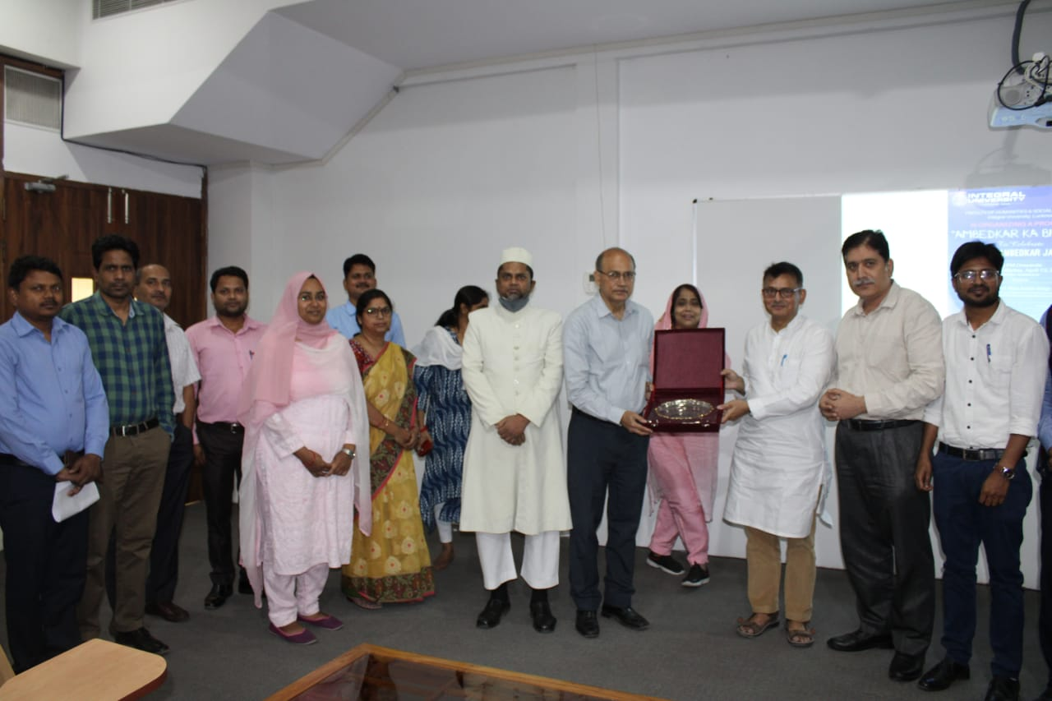 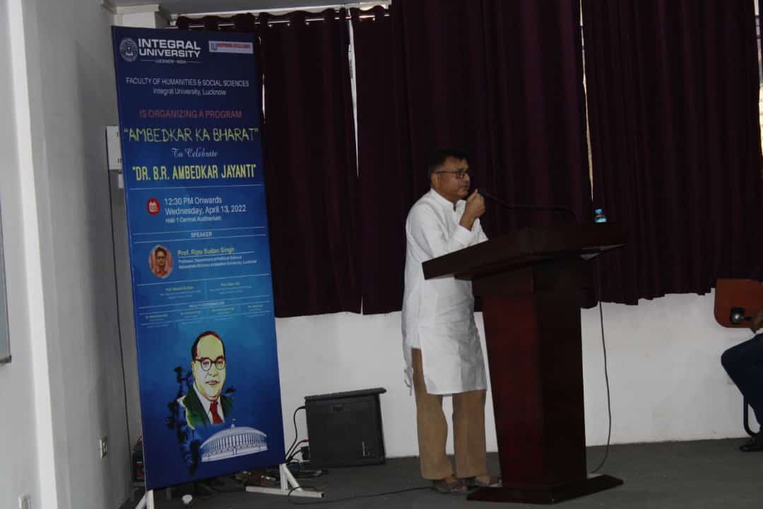

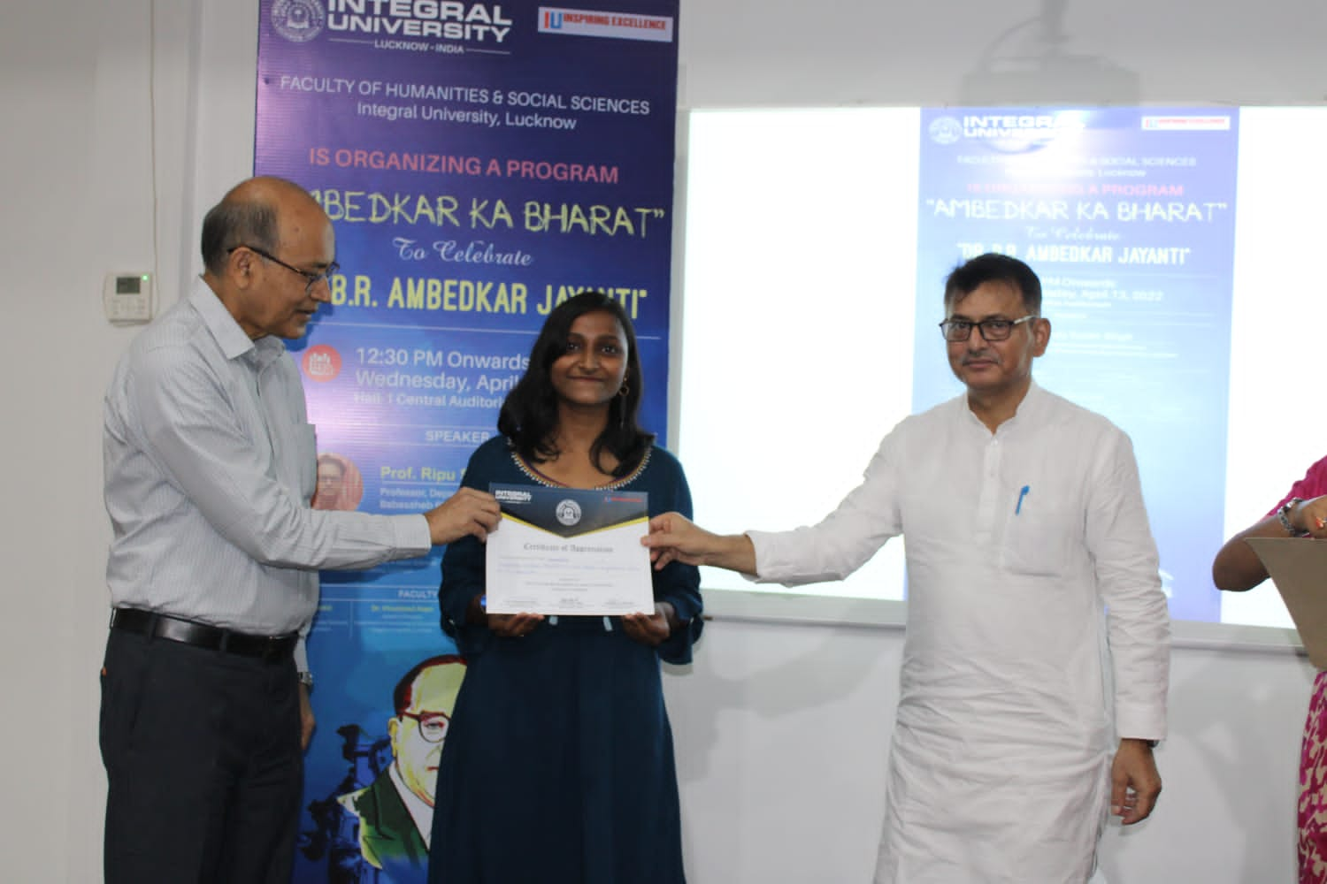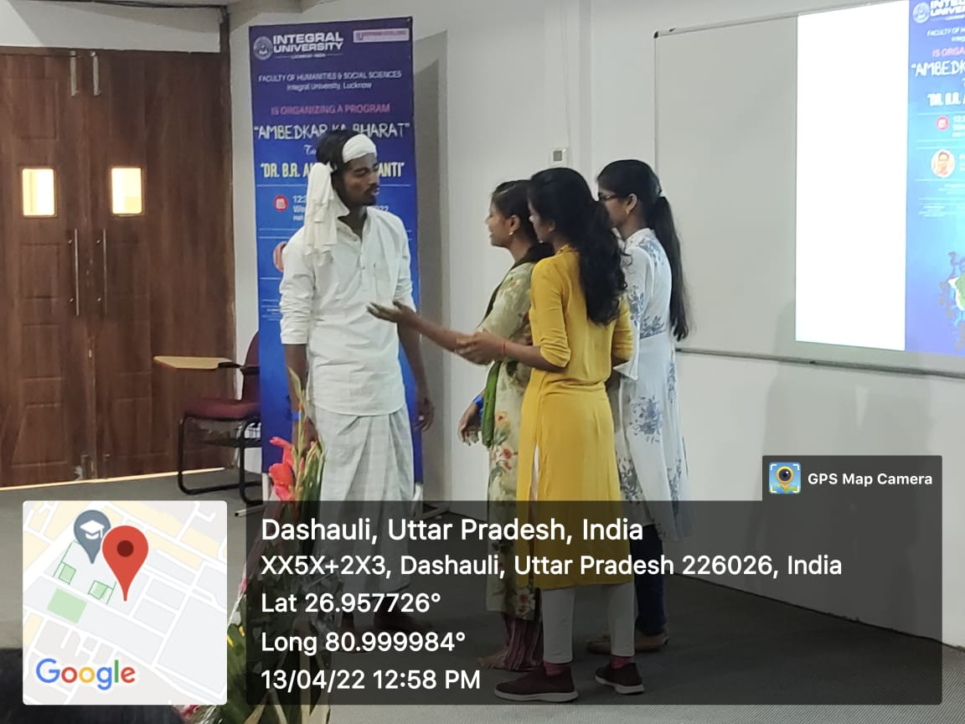

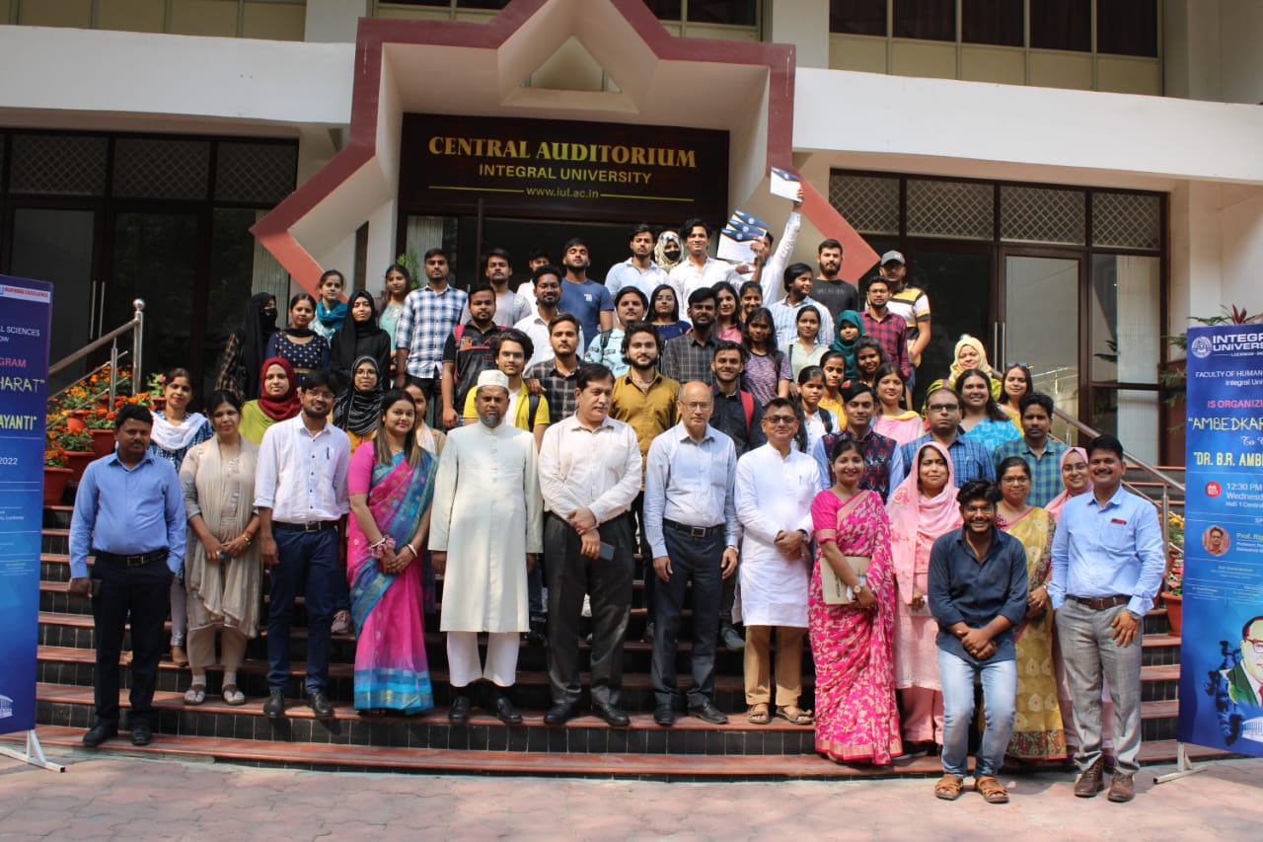

Regards

Prof. Zeba Aqil

Head

Deptt. of Humanities & Social-Sciences

Integral University